Catalog

**Bear**

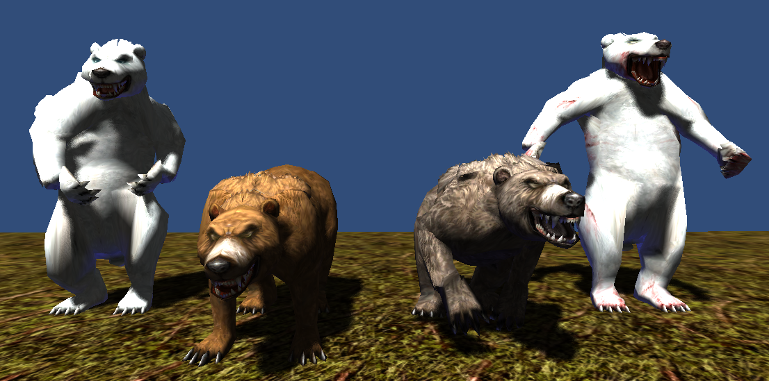

1506 polygons

512x512x32bit 1 texture

6 animations(idle, idle2, move, attack, beaten, die)

**Mermaid**

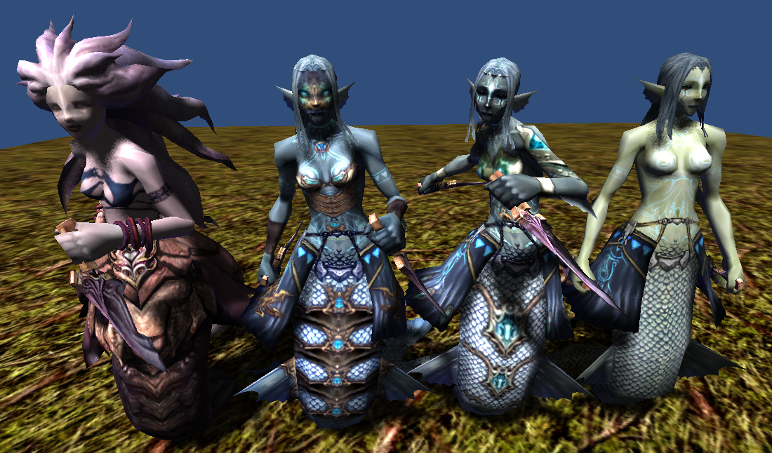

1680 polygons (Unique 6968 polygons)

512x512x32bit 1 texture

128x256x32bit 1 texture (Dagger)

6 animations(idle, idle2, move, attack, beaten, die)

**Orc**

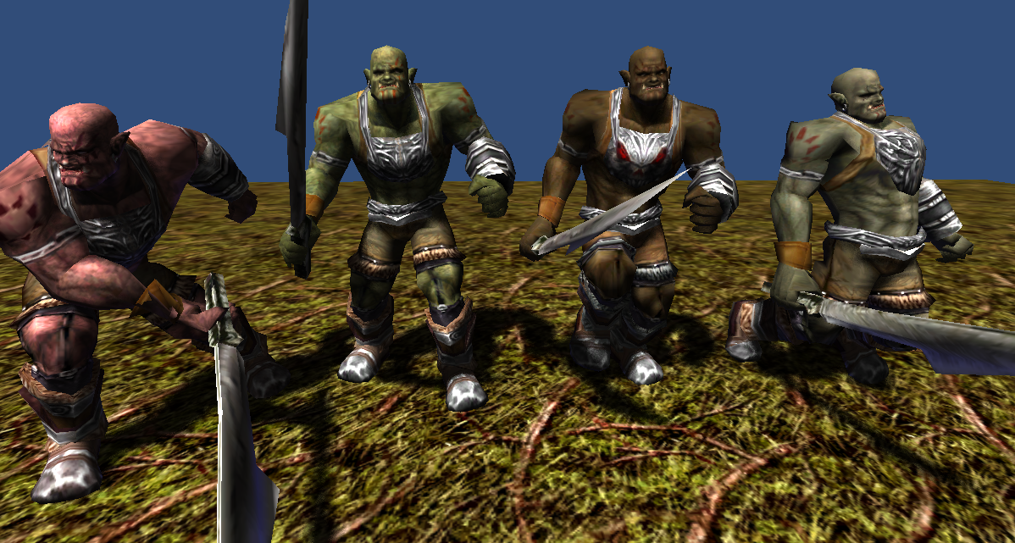

2494 polygons

512x512x24bit 1 texture

64x128x24bit 1 texture (sword)

5 animations(idle, move, attack, beaten, die)

**Orc Archer**

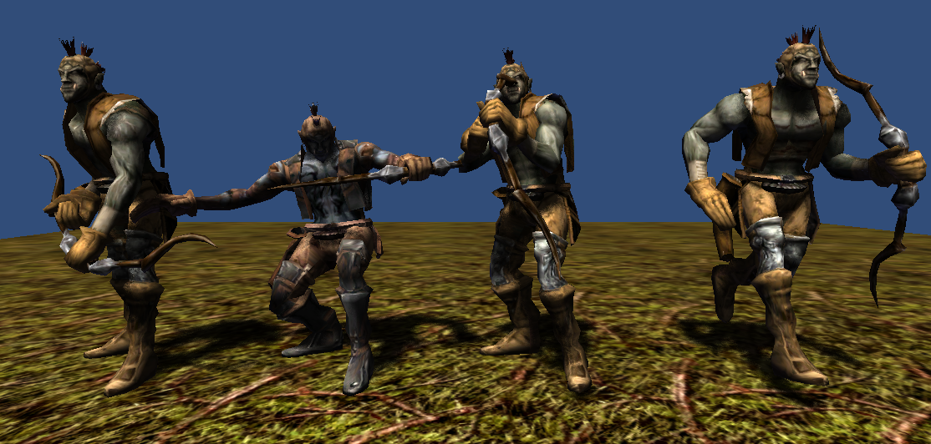

2642 polygons

512x512x24bit 1 texture

5 animations(idle, move, attack, beaten, die)

**Thank you for download.**

**Contact**

Homepage : http://www.studioez.net

E-Mail : admin@studioez.net